# ASSIGNMENT-2

Kamala Varthini.G

421319106018

IOT Based Safety Gadgets for Child Safety Monitoring & Notifiction

**Program for temperature and humidity to indicate alarm continuous in high temperature using generated random variables:**

import random while(True):

temp=random.randint(20,100) hum=random.randint(20,100)

if(temp>=60 and hum<=90):

print("High temperature values of temperature and humidity is:",temp,hum);

print("Alarm ON");

elif(temp<60 and hum>90):

print("Low temperature values of temperature and humidity is:",temp,hum);

print("Alarm OFF");

# OUTPUT:

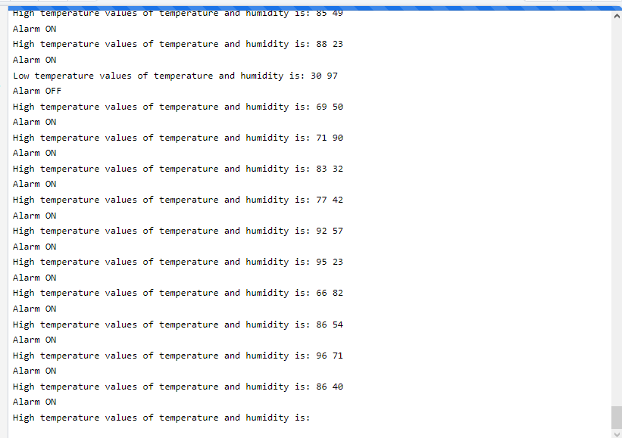

**High femperafure values of femperafure and fium181¥y 1s: 61 80**

Alarm or�

**High temperature values of temperature and** humidity **is:** 99 62

## Alarm ON

**High temperature values of temperature and** humidity **is:** 82 50

Alarm or�

**High temperature values of temperature and** humidity **is:** 65 85

## Alarm ON

**High temperature values of temperature and** humidity **is:** 62 44

Alarm or�

**High temperature values of temperature and** humidity **is:** 98 69

## Alarm ON

**High temperature values of temperature and** humidity **is:** 85 72

## Alarm ON

**High temperature values of temperature and** humidity **is:** 87 23

Alarm or�

**High temperature values of temperature and** humidity **is:** 63 85

## Alarm ON

**High temperature values of temperature and** humidity **is:** 96 33

Alarm or�

**High temperature values of temperature and** humidity **is:** 65 24

## Alarm ON

**High temperature values of temperature and** humidity **is:** 84 42

Alarm or�

**High temperature values of temperature and** humidity **is:** 82 51

## Alarm ON

**High temperature values of temperature and humidity is:**